Test and Investigation of Video Learning Project

By Tuan Nghia Nguyen

**Abstract:**

This paper is conducted by taking the already developed framework of Hierarchical Temporal Memory (HTM) which is used to Learn Videos, then putting it under various conditions by modifying different parameters to test it’s performance.

Keywords—HTM, Video Learning, frame, HTM configurations

1. **Introduction:**

The project is based on the project of HTM Video Learning [1], which is also originated from the HTM Project with the ideas of Sequence Learning. However, instead of scalars, inputs of images were used. The Video Learning program is already finished but it’s performance was not thoroughly tested for all of the functions and features. Therefore, the main goal of the project is to test the software with various parameters, inputs then document the results. Finally, based on these experiments, different aspects of the project are concluded to determine if the project’s direction was good enough, with the possibility of an improvement proposal.

1. **Methodology:**

The aforementioned project of Video Learning with HTM functions by using Temporal Memory to learn binary representation of videos (sequence of bit-arrays, with each bit-array represents 1 frame). This whole experiment was conducted with the input of randomly chosen videos to ensure the project’s objectivity in order to evaluate the video learning process’s performance more accurately. Firstly, the video’s input folder path were dragged into of the program. After the period of run time, the result of the learning process was determined by how well the trained model could predict the next frame of the video based on what it had learned, when a specific frame was assigned to the model. Finally, an image (or a frame) was provided to the trained model. The model then attempted to recreate a video with proceeding frame after the input frame[1]. The model’s performance was assessed by two aspects: the accuracy and the elapsed time of the learning process. These aspect’s data were obtained by experimenting with two types of inputs:

Simple Shape inputs:The first experiment was running the program with many set of simple videos, in which only basic shapes (a black circle, triangle and rectangle) moving around on a white background. The difference between these sets is the angle that these shape moves. By changing the parameter in the python code, different set of videos with different moving angle (varies from 0 to 360 degree) can be generated.

Youtube Video input: For other parameters, a random music video on Youtube (“Never Gonna Give You Up” by Rick Astley is used in this case) is edited down to a small 5-second video which is used as an input for the learning process of the program. The editing is done by an online video editor called Kapwing[2]. This video was put under many different conditions, such as by changing the video’s resolutions or the HTM configurations of the program, including Cells per column, Global Inhibition, Max Boost, etc.

For most of the parameters, both operating modes of the program are used (Run1 and Run2), except those regarding HTM configuration (only Run2). The reason behind would be explained in the Discussion section.

1. **Result:**
2. **Angle Experiments with Simple Shape inputs:**

Run1 was only run with Max Cycle = 10 to see the difference between each case of the experiment, since elapsed time of Run1 with Max Cycle = 1000 took much longer for each case than Run2. Therefore, the average accuracy for Run1 is much lower than Run2.

**Run1: Max Cycle = 10**

|  |  |  |  |  |  |
| --- | --- | --- | --- | --- | --- |
| **Angle** | 36 | 72 | 108 | 144 | 180 |
| **Accuracy** | 0.73 | 0.61 | 0.73 | 0.75 | 0.64 |
| **Elapsed time** | 7min | 5min | 7min | 6min | 15min |

**Run2: Max Cycle = 1000**

|  |  |  |  |  |  |
| --- | --- | --- | --- | --- | --- |
| **Angle** | 36 | 72 | 108 | 144 | 180 |
| **Accuracy** | 0.93 | 0.91 | 0.88 | 0.88 | 0.88 |
| **Elapsed time** | 7min | 10min | 7min | 11min | 11min |

1. **Resolution Experiments with Youtube Video input:**

**Run1: Max Cycle = 10**

|  |  |  |  |  |  |
| --- | --- | --- | --- | --- | --- |
| **Resolution** | 18x18 | 30x30 | 40x40 | 50x50 | 50x25 |
| **Accuracy** | 0.58 | 0.68 | 0.78 | 0.69 | 0.59 |
| **Elapsed time** | 4min | 10min | 21min | 37min | 16min |

**Run2: Max Cycle = 1000**

|  |  |  |  |  |  |
| --- | --- | --- | --- | --- | --- |
| **Resolution** | 18x18 | 30x30 | 40x40 | 50x50 | 50x25 |
| **Accuracy** | 0.92 | 0.98 | 0.90 | 0.90 | 0.98 |
| **Elapsed time** | 6min | 7min | 12min | 7min | 8min |

1. **HTM Configuration Experiments with Youtube Video input:**

**Default HTM configuration:**

private static HtmConfig GetHTM(int[] inputBits, int[] numColumns)

{

HtmConfig htm = new(inputBits, numColumns)

{

Random = new ThreadSafeRandom(42),

CellsPerColumn = 30,

GlobalInhibition = true,

//LocalAreaDensity = -1,

NumActiveColumnsPerInhArea = 0.02 * numColumns[0],

PotentialRadius = (int)(0.15 * inputBits[0]),

//InhibitionRadius = 15,

MaxBoost = 10.0,

//DutyCyclePeriod = 25,

//MinPctOverlapDutyCycles = 0.75,

MaxSynapsesPerSegment = (int)(0.02 * numColumns[0]),

//ActivationThreshold = 15,

//ConnectedPermanence = 0.5,

// Learning is slower than forgetting in this case.

//PermanenceDecrement = 0.15,

//PermanenceIncrement = 0.15,

// Used by punishing of segments.

};

return htm;

}

For this experiment, each below parameter is modified independently, while the others remained the same as the default HTM Configuration. The value of N/A indicates the experiment required too long an elapsed time without reaching a specific result. Therefore, they were cancel.

**Cells per column:**

|  |  |  |  |  |  |
| --- | --- | --- | --- | --- | --- |
| **Parameter** | 30 | 40 | 60 | 80 | 100 |
| **Accuracy** | 0.81 | 0.88 | 0.82 | 0.90 | 0.84 |
| **Elapsed time** | 6min | 7min | 12min | 7min | 8min |

**Switch Global Inhibition = false:**

**Accuracy:** 0.88

**Elapsed Time:** 40min

**Enable LocalAreaDensity:**

|  |  |  |  |
| --- | --- | --- | --- |
| **Parameter** | -1 | 0 | 1 |
| **Accuracy** | 0.85 | 0.91 | N/A |
| **Elapsed time** | 14min | 22min | N/A |

**NumActiveColumnsPerInhArea with modified constant:**

|  |  |  |  |  |
| --- | --- | --- | --- | --- |
| **Constant** | 0.01 | 0.02 | 0.03 | 0.04 |
| **Accuracy** | 0.95 | 0.86 | 1 | 1 |
| **Elapsed time** | 16min | 10min | 25min | 30min |

**PotentialRadius:**

|  |  |  |  |  |
| --- | --- | --- | --- | --- |
| **Constant** | 0.15 | 0.2 | 0.3 | 0.1 |
| **Accuracy** | 0.86 | 0.81 | 0.99 | 0.99 |
| **Elapsed time** | 10min | 11min | 32min | 14min |

**Enable InhibitionRadius:**

|  |  |  |  |  |  |
| --- | --- | --- | --- | --- | --- |
| **Parameter** | 40 | 50 | 60 | 70 | 80 |
| **Accuracy** | 0.92 | 0.82 | 0.85 | 0.90 | 0.84 |
| **Elapsed time** | 18min | 13min | 21min | 16min | 15min |

**MaxBoost:**

|  |  |  |  |  |  |
| --- | --- | --- | --- | --- | --- |
| **Parameter** | 10 | 20 | 30 | 40 | 50 |
| **Accuracy** | 0.81 | 0.88 | 0.81 | 0.81 | 0.85 |
| **Elapsed time** | 6min | 22min | 20min | 15min | 10min |

**Enable DutyCyclePeriod:**

|  |  |  |  |  |  |
| --- | --- | --- | --- | --- | --- |
| **Parameter** | 50 | 60 | 70 | 80 | 90 |
| **Accuracy** | 0.86 | 0.89 | 0.89 | 0.81 | 0.96 |
| **Elapsed time** | 10min | 38min | 19min | 12min | 19min |

**Enable MinPctOverlapDutyCycles:**

|  |  |  |  |  |  |
| --- | --- | --- | --- | --- | --- |
| **Parameter** | 0.5 | 0.75 | 1.0 | 1.25 | 1.5 |
| **Accuracy** | 0.86 | 0.82 | 0.81 | 0.86 | 0.85 |
| **Elapsed time** | 10min | 21min | 20min | 8min | 13min |

**Enable MaxSynapsesPerSegment with modified constant:**

|  |  |  |  |  |  |
| --- | --- | --- | --- | --- | --- |
| **Constant** | 0.02 | 0.03 | 0.04 | 0.05 | 0.1 |
| **Accuracy** | 0.82 | 0.88 | 0.84 | 0.81 | 0.82 |
| **Elapsed time** | 7min | 13min | 28min | 12min | 18min |

**Enable ActivationThreshold = 10: N/A**

**Enable ActivationThreshold = 20: N/A**

->Only with ActivationThreshold = 15

**Enable ConnectedPermanence:**

|  |  |  |  |
| --- | --- | --- | --- |
| **Parameter** | 0.5 | 0.75 | 1.5 |
| **Accuracy** | 0.97 | 0.89 | 0.84 |
| **Elapsed time** | 25min | 36min | 27min |

**Enable PermanenceDecrement = 0.15:**

**Accuracy:** 0.84

**Elapsed Time:** 11min

**Enable PermanenceIncrement = 0.15:**

**Accuracy:** 0.81

**Elapsed Time:** 14min

**Enable both PermanenceIncrement and PermanenceDecrement:**

|  |  |  |  |  |
| --- | --- | --- | --- | --- |
| **Both Parameter** | 0.15 | 0.2 | 0.25 | 0.3 |
| **Accuracy** | 0.96 | 0.97 | 0.95 | 0.95 |
| **Elapsed time** | 17min | 31min | 12min | 13min |

1. **Discussion:**

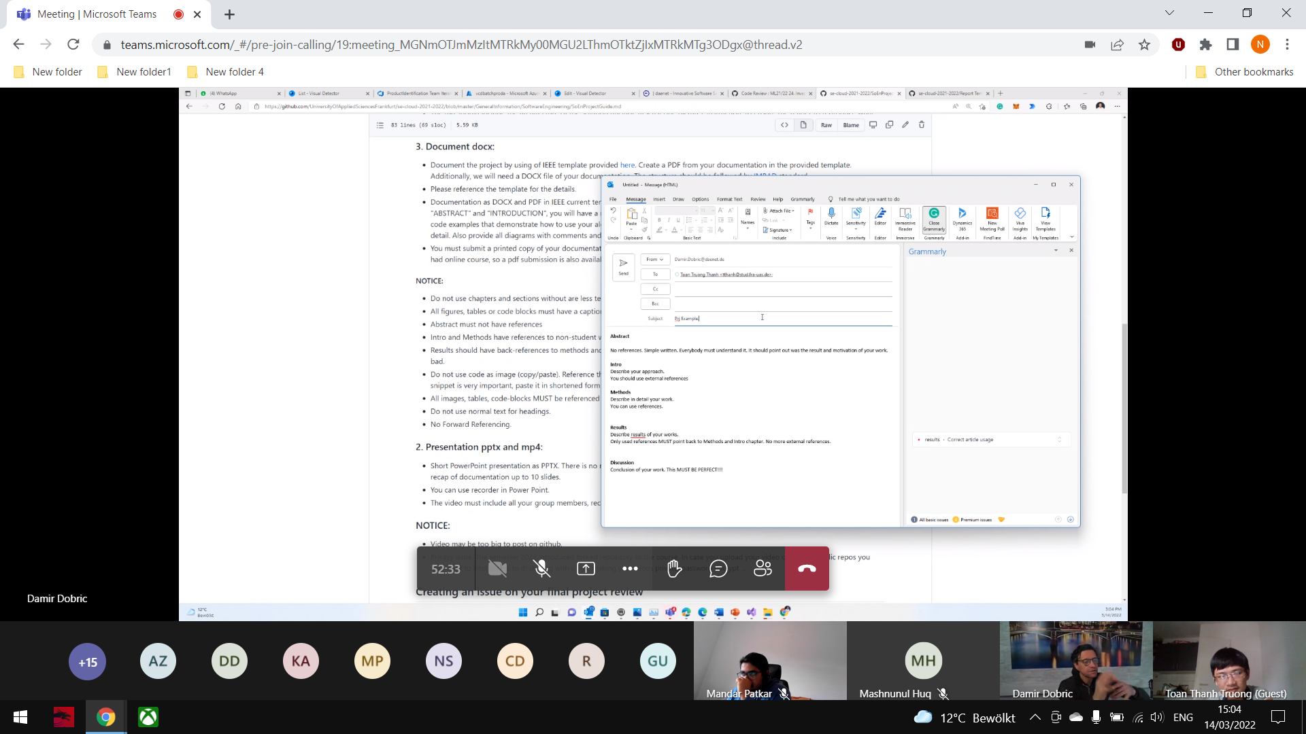

1. **Reference:**